Grade 4 Science: Wheels and Levers Performance Task
Wheels and Levers:
The machines we use everyday help to make our lives easier. During the course of this unit, students learned about different simple machines. The final performance task for this unit challenges students to invent a machine that makes work easier. Students have the OPTION to either build their invention OR create a blueprint (poster) depicting their invention.
Students will be presenting their to the class on Monday November 9th, 2015.
Each student’s inventions MUST INCORPORATE AT LEAST ONE SIMPLE MACHINE; should be unique and solve a specific problem or improve an existing item. No batteries, electronics or engines.
Use the lists below for ideas on situations that your invention could be used in or problems that can be solved/ improved.

- • garden/farm
- • kitchen/restaurant
- • office/school
- • garage
- • on a boat
- • playground/amusement park
- • new musical instrument
- • new cleaning tool
- • new toy
- • new product for pets
- • new toothbrush holder
- • new birdfeeder
- • new back pack
- • new container
- • way of keeping drinks cold
- • way of organizing pencils
- • way to prevent spills
- • new garbage collection method
- • way to clean your room
- • way to do the dishes

Simple machines covered in class:

        - - Gear
- - Inclined Plane
- - Pulley
- - Rollers
- - Wedge
- - Screw
- - Wheel and Axle
- - Levers (1st class, 2nd class, 3rd class)

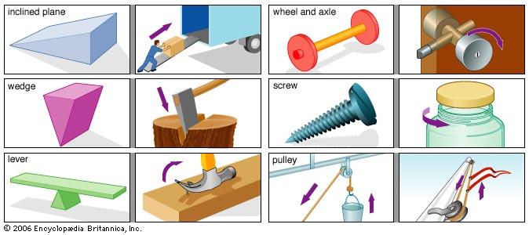
Wheels and Levers Invention Checklist
o Invention uses at least one simple machine effectively
o Invention solves a problem or makes work easier
o Invention is unique, creative and useful
Resources for Research:
o http://stephaniekoller.wix.com/grade4#!science/c1fue
http://www.lakelandschools.us/do/lbrandon/Machines/Machines.htm

Visit each of the Web Sites below to learn about simple machines and to get ideas for
your project.

 | Inquiry Almanac - Here you will find the names and descriptions of different types of simple machines. This website explains how each machine works.
 | Dirtmeister's Simple Machines - Learn more about simple machines at this site.
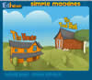 | Edheads - Explore the garage and tool shed and identify the simple machines found there.
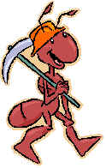 | Beacon Learning Center - Wally the working ant will be your guide to help you master important vocabulary about simple machines.
 | MIKIDS.com - You’ll find lots of examples of each simple machine at his site.
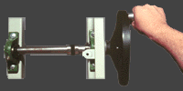 | Inventor's Toolbox - Explore this site to get ideas for your invention. Use Gadget Anatomy to quiz yourself to see how well you understand simple machines.
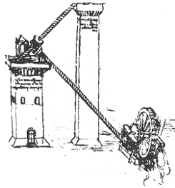 | Exploring Leonardo - Leonardo da Vinci was a famous painter, scientist, and inventor. Visit the Inventor's Workshop to explore some of his ideas. Play Leonardo's Mysterious Machinery and try to identify the simple machines he used.

Wheels and Levers Invention Presentation Checklist for Invention Presentation
o Demonstrate and describe the use of each simple machine
o Share ideas in an organized way
o Speak with appropriate gestures, volume, tone and clarity
